**COVID-19 Portfolio Project- Data exploration and Data Manipulation using SQL**

**Let’s have an overview of the Covid-19 Data:**

**Select all the data**

MySQL> select * from CovidDeaths;

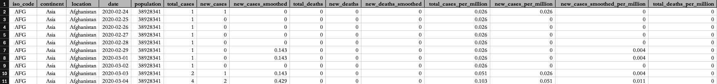

**Total cases vs Total Deaths**

MySQL> select location, date, total_cases, total_deaths, (total_deaths/total_cases) * 100 as DeathRatio from CovidDeaths where location like '%states%' order by DeathRatio desc;

**Likelihood of contracting COVID-19**

MySQL> Select Location, date, total_cases,total_deaths, (total_deaths/total_cases)*100 as DeathRatio from CovidDeaths Where location like '%states%' and continent != '' order by date desc, DeathRatio desc;

**From the image below,**

**#1:**

**The initial peak covid data shows that the total cases skyrocketed from 55 to 107.**

**#2:**

**The total cases peaked from November 8, 2020 with over 10M+ cases with a DeathRatio of 2.37%.**

**#3:**

**The DeathRatio also plummeted to 1.7% in the later stage.**

**This shows that you have 1.7% chance of contracting COVID-19**

**Shows the percentage of population got covid**

MySQL> select location, date, population, total_cases, (total_cases/population)

* 100 as DeathRatio from CovidDeaths where location like '%states%' order by DeathRatio desc;

**Looking at countries with highest infection rate vs population**

**MySQL> select location, population, Max(total_cases) as HighestInfectionCount, Max((total_cases/population)) * 100 as PercentPopulationInfected from CovidDeaths group by location, population order by PercentPopulationInfected desc;**

**Showing the countries with highest death count per population**

MySQL> select location, max(cast(total_deaths as UNSIGNED)) as TotalDeathCount from CovidDeaths where continent != '' group by location order by TotalDeathCount desc;

**Breaking things down by continent**

**showing deaths count by continent**

MySQL> select date, sum(new_cases) as TotalCases,sum(new_deaths) as TotalDeaths, sum(new_deaths) / sum(new_cases) * 100 as DeathPercent from CovidDeaths where continent != '' group by date order by 1,2; — globally

MySQL> select continent, max(cast(total_deaths as UNSIGNED)) as TotalDeathCount from CovidDeaths where continent != '' group by continent order by TotalDeathCount desc;— continent

MySQL> select sum(new_cases) as TotalCases, sum(new_deaths) as TotalDeaths, sum(new_deaths) / sum(new_cases) * 100 as DeathPercent from CovidDeaths where continent!= '' order by 1,2;— across the world

**Looking for total pop vs Vacc**

MySQL> With PopvsVacc (continent, location, date, population, new_vaccinations, RVacc) as (select d.continent, d.location, d.date, d.population, v.new_vaccinations, sum(cast(v.new_vaccinations as unsigned)) over (partition by d.location order by d.location, d.date) as RVacc from CovidDeaths as d JOIN CovidVaccinations as v on d.location = v.location and d.date = v.date where d.continent != '') select *, (RVacc/population) * 100 from PopvsVacc limit 1000;

**Creating a temp table**

MySQL> Drop temporary table if exists PercentPopVaccinated; create temporary table PercentPopVaccinated (continent varchar(50), location varchar(100), date DATE, population bigint, new_vaccinations bigint, RVacc bigint); insert into PercentPopVaccinated select d.continent, d.location, d.date, d.population, v.new_vaccinations, sum(cast(v.new_vaccinations as unsigned)) over (partition by d.location order by d.location, d.date) as RVacc from CovidDeaths as d JOIN CovidVaccinations as v on d.location = v.location and d.date = v.date; select *, RVacc/population * 100 as PercentVaccinated from PercentPopVaccinated limit 1000;

**Creating a view**

MySQL> create view PercentPopVaccinated as select d.continent, d.location, d.date, d.population, v.new_vaccinations, sum(cast(v.new_vaccinations as unsigned)) over (partition by d.location order by d.location, d.date) as RVacc from CovidDeaths as d JOIN CovidVaccinations as v on d.location =

v.location and d.date = v.date where d.continent != '' limit 1000;